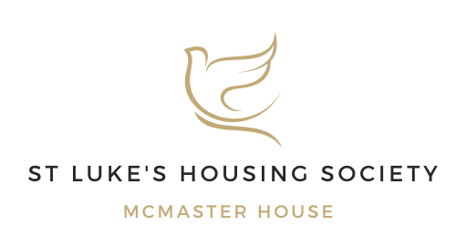
Board Response
Annual Complaints Performance and Service Improvement Plan 2024-25
At St Luke’s Housing Society, we are committed to providing the best service for our residents at McMaster House. We have completed the Self-Assessment for 2024-25, following the Housing Ombudsman Complaint Handling Code.
At the Board, we discuss our complaints handling at quarterly meetings. We are satisfied that our self-assessment is a true reflection of how we manage complaints at our association and that we comply with the code.
Our complaints policy and procedure were updated in 2024 to reflect the new code requirements, and these changes have been implemented. These are outlined within our Annual Complaint Performance and Service Improvement Report.
As per our previous response for 2023-24, we recognise that there is always room for improvement in the way we deliver our services. We remain committed to improving the services we deliver to our residents.
We carried out the most recent Tenant Satisfaction Measures (TSM) survey in Ma 2025. We had one formal complaint made for the period, which was investigated and concluded. We are satisfied that our approach to complaint handling is carried out following the complaint handling code, and we continue to look at our processes and responses to ensure we are able to keep complaints to a minimum.
As our staff are on site most days during the week and have a good understanding of scheme matters and residents' needs. We continued to receive very few formal complaints, and any ‘observations to improve things’ are addressed very swiftly.
The Board will continue to work with our Head of Operations and other staff to support them with the complaint handling process.
As a Board, we fully endorse the report to the Ombudsman and that it accurately reflects our current situation. We will continue to monitor our complaints handling at each quarterly board meeting and regular check-ins with our staff.
Malcolm Fearn
Chair of Trustees
St Luke’s Housing Society

